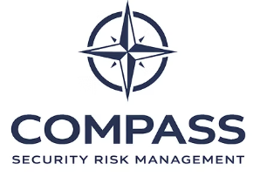

Privacy Policy
Compass Security Risk Management (CSRM)
Compass Security Risk Management (CSRM) respects your privacy and is committed to protecting any personal information you provide when using this website.
This policy explains how information is collected, used, and protected when you visit https://www.compasssrm.com.

Information We Collect
When you contact us through this website, we may collect basic personal information such as:
• Name
• Email address
• Contact details
• Information provided within your enquiry
This information is used solely to respond to enquiries, provide requested information, or discuss potential services.
We do not sell, rent, or distribute personal information to third parties unless required by law or necessary to provide services requested by you.

Website Analytics
This website may collect anonymous usage data through third-party analytics services. This helps us understand how visitors interact with the website so we can improve the information and services we provide.
This data does not identify individual users.

Cookies
Cookies are small files stored on your device that help improve the functionality and performance of the website.
This site may use cookies to:
• ensure essential website functionality
• understand website usage and improve performance
You can adjust your browser settings at any time to control or disable cookies.

Data Security
Compass Security Risk Management takes reasonable steps to protect personal information against unauthorised access, disclosure, or misuse.
Personal information will only be retained for as long as necessary to respond to your enquiry or fulfil the purpose for which it was provided.

International Data Transfers
Due to the nature of internet infrastructure, information submitted through this website may be stored or processed on servers located outside your country of residence.
By using this website, you consent to such transfers.

External Links
This website may contain links to external websites. Compass Security Risk Management is not responsible for the privacy practices or content of third-party websites.

Social Media
Interactions with Compass Security Risk Management through social media platforms are governed by the privacy policies of those platforms.
We will never request sensitive personal information through social media channels.

Your Rights
Under applicable data protection laws, you may request access to, correction of, or deletion of your personal data.
To make a request or ask questions regarding this policy, please contact:
info@compasssrm.com

Policy Updates
This privacy policy may be updated periodically to reflect changes in legal requirements or business practices.

